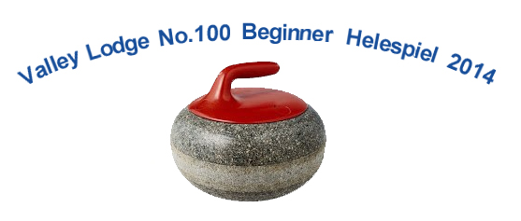

Valley Lodge No. 100 is hosting their annual beginner bonspiel on February 22, 2014.
You may remember the first time you played shuffle board in a friend’s basement or a pub (shuffle board was big in the 70’s – you know before video games). You had a quick introduction from a friend, a couple of practice throws and then you were into game for the afternoon (or evening as the case maybe).
Four years ago I was introduced to curling at the Valley Lodge event. I thought, “It can be that much different than Shuffleboard from my teenage years can it?” I am a Canadian I know what it is like to be on the ice, and I have seen curling on TV – the Tim Hortons Brier right?
I had two friends that knew as much as I did about the sport and were willing to give it a try. I thought, “Should we give it a go?” sure there were things we didn’t know. Some of the terms for instance like: rock, sheet, button, or house; that wasn’t going to stop us. So what if we didn’t know when or why one needs to sweeps. Seriously - how could we go wrong?
The answer is we couldn’t. We had a great time! We have picked up a fourth player and have been back every year ever since. We still don’t know a draw from a draw raise or how to use the measuring device for close calls. But we can fake it pretty good. None of that did stop us from placing 2nd last year.
This year we are going for the gold!
If you want to join us in the fun this year’s here are the details:
Valley Lodge’s Beginner Bonspiel.
Saturday, February 22nd at the Dundas Granite Curling Club
Tickets are $55.00 per person
There will be a light breakfast and a catered lunch provided
Contact W.Bro. John Mackay for tickets: 905-632-7412

